EXP 15

AIM: Design TM using simulator to accept the input string a^nb^n

INPUT:

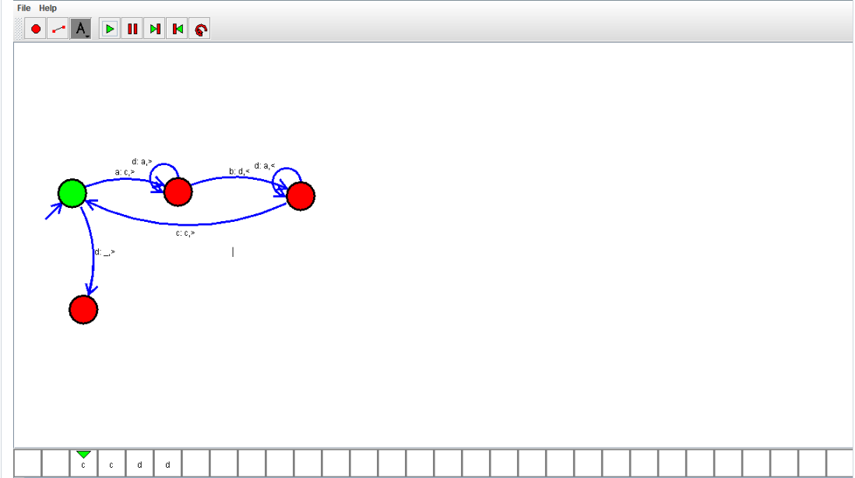

OUTPUT:



RESULT: Design TM using simulator to accept the input string a^nb^n Is successfully executed